**Gwei Lun-mei**



Gwei Lun-mei was born on Christmas day of 1983 in Taipei, Taiwan and is known for her girl-next-door, innocent looks. She is 1.64 meters tall. Gwei attended We Ge High School and had her college education at Tamkang University where she studied for a French literature degree before proceeding to University of Lyon in Lyon, France for further studies. Gwei speaks four languages namely Mandarin, French, English, and Taiwanese.

She made her acting debut in the movie Blue Gate Crossing (2002). However, her breakthrough was not to come until 2007 when she starred as the lead female playing the character of Lu Hsiaoyu in the film *Secret (2007)* that was directed by Jay Chou. Thereafter it was plain sailing and by 2011 she was ready to start collecting awards.

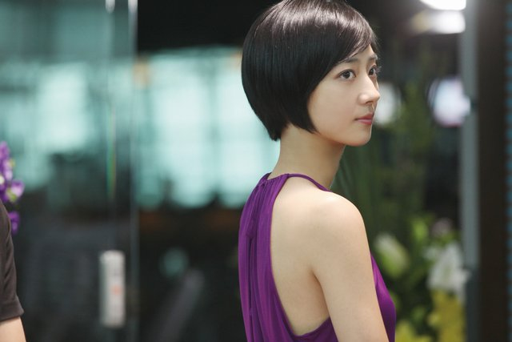

She was nominated for the Best Actress Award at the 2nd China Film Director's Guild Awards for her performance in a starring role in *The Stool Pigeon* in 2011. The Hong Kong Film Critics Society also nominated her for the Best Actress Award for the same role she played in *The Stool Pigeon.*



In 2012, she won, at the 49th Golden Horse Film Awards, the Best Leading Actress Award for playing the lead role in Girlfriend Boyfriend (2012). The film was a coming-of-age drama set in the Taiwan's martial law period (1949–87) and featured three teenagers exploring their emotional attractions in an environment of newfound freedom in the society. The other two characters in the drama were played by Joseph Chang and Rhydian Vaughan. In the same year she also won the Asia-Pacific Film Festival Best Actress.



In 2014 she was awarded the Students' Choice Award for Favorite Actress at the 21st Beijing College Student Film Festival. A part from these she has been nominated in several other platforms for awards almost every year since 2011. In 2014, she was appointed Golden Horse Ambassador. Gwei admitted that she was over the moon with this appointment, especially to follow in the footsteps of the previous year's ambassador, Maggie Cheung.

Gwei is not married but has entered into a romantic relationship with an actor and film maker Leon Dai that has lasted since 2004 and is still ongoing. However, rumor has it that she is in some compromising relationship with Blue Gate Crossing co-star Bolin Chen. However it must be said that her relationship with Leon Dai has endured the test of times.

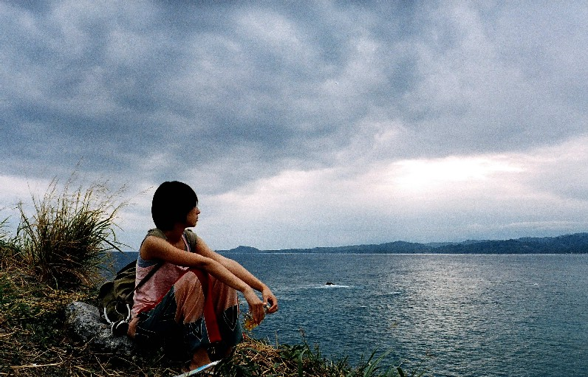

Gwei Lun-mei has been quoted as saying that she has never considered marriage with anyone. HK Top Ten quoted her as saying that she believes more in the stability of relationships than in the formalization of relationships. Gwei stated as follows, "Leon and I are satisfied with our current status and our relationship has made me even more ambitious about my career".

Apart from acting, Gwei has appeared in several music videos for other artists such as Tanya Chua and Tanya Cai. Her successes both on and off the stage have attracted attention of advertisers and in 2014 she was appointed the new brand ambassador for Montblanc.

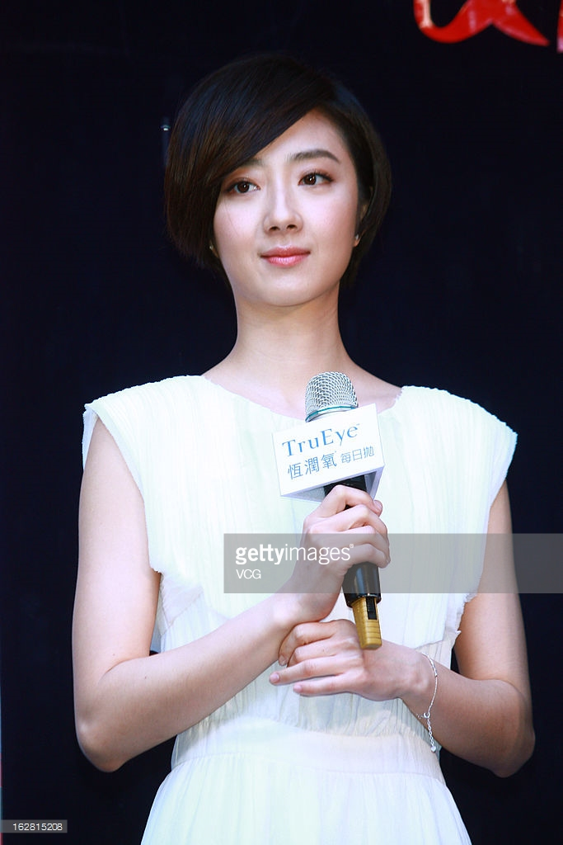

She impressed everyone at Gwei at the launch of the Bohème Collection in Shanghai, China when she said “I’m the sort of person who does what I want whether it is in my career or personal life so I can definitely relate to the Bohème spirit which is about independence, maturity and freedom. The collection is for the woman who knows what she wants and who dares to go after her dreams – like me. I don’t know what the future holds so whatever I want to do, I will do it to the best of my ability. At age 30, I feel lucky to be the luxury brand’s ambassador because now I know that the logo represents top notch craftsmanship and creativity.”